3D File Translator

* Open the FileTranslator3d.sln in visual studio 2019.
* Set following projects as startup projects.

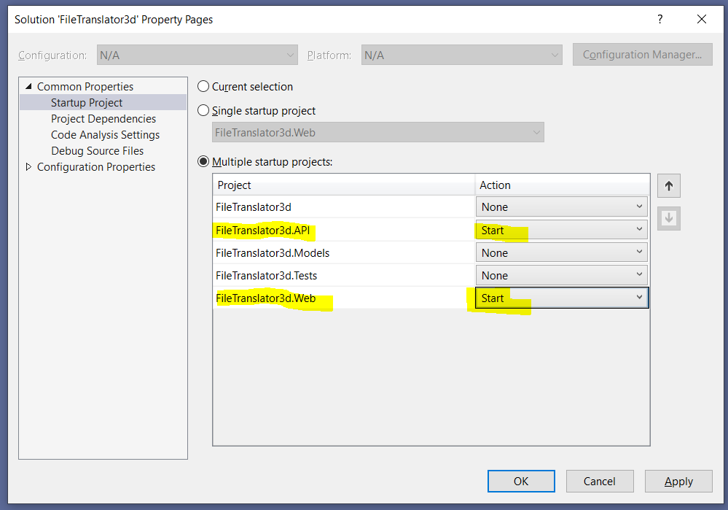

* Build and Click on Start or IIS Express button to run the solution.
* It will start two web pages. (1. For web application and 2. For web API project)
* After running the solution it will show following UI on the web application.

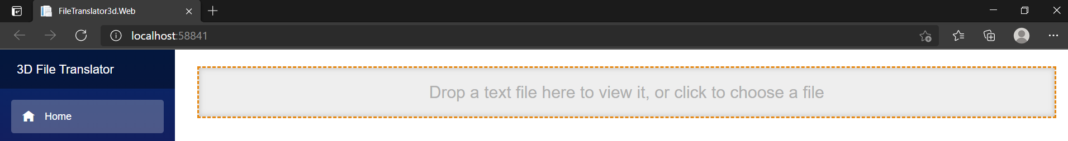

* Drag and drop the obj file or click on the highlighted text.
* File browser dialog will open and select an obj file.
* After selecting the file UI will change and more options will appear.

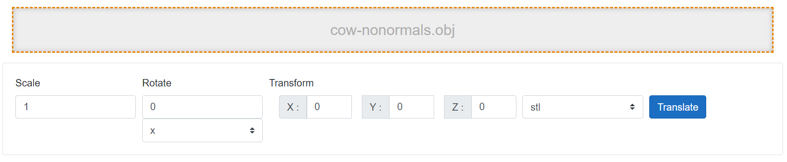

* Specify the desired parameters here. The output format is STL by default. Other operations are given only for reference purpose.
* Once desired values are entered in the UI above click on the translate button to convert OBJ file to STL format.
* After successful conversion, the UI will show success message and area as well as volume on the screen.

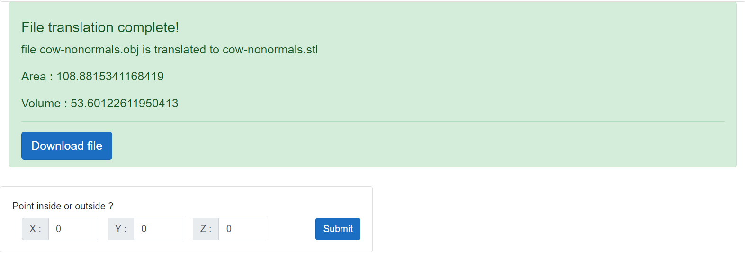

* Now, specify the point coordinates and click on submit button. To check if point is inside make sure you enter proper coordinates.
* If the point is inside it will display message as shown below.

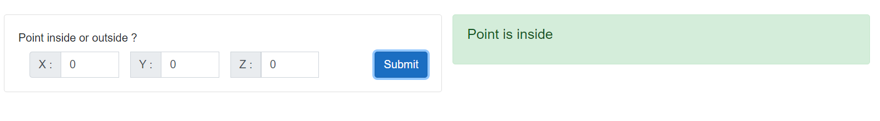

* Otherwise

